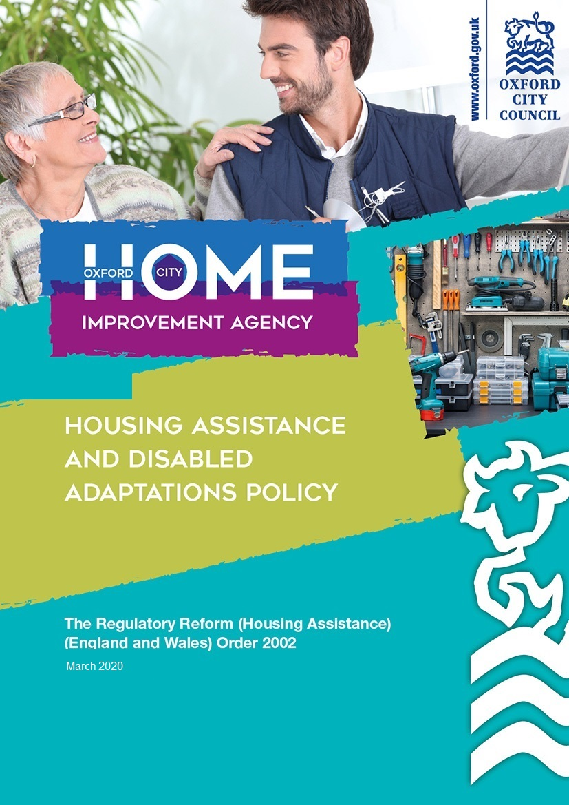

1. Introduction

1.1 The Council aims to be as helpful to potential applicants for financial assistance as resources will allow. It is happy to give guidance and advice to Older, Disabled and vulnerable clients regardless of whether they are eligible for financial assistance. At times of heavy demand it will be obliged to prioritise the workload and it may have to operate waiting lists.

1.2. The Council is duty bound to approve applications made under section 23(1) of the Housing Grants, Construction and Regeneration Act 1996 that satisfy the requirements of that Act, for example mandatory Disabled Facilities Grants (DFG).

1.3 In 2002 the government brought in the Regulatory Reform (Housing Assistance) (England and Wales) Order 2002 which provide freedom and opportunities for the Local Authority to address housing issues. In 2008-9 the government extended the scope of the RRO to include use of the DFG money. This enables the authorities to use specific DFG funding for wider purposes. The Council has discretionary powers under “the Order” to provide assistance in any form for the purpose of improving living conditions.

1.4 DFG funds are not permitted to be used for Local Authority owned properties, so this policy does not apply to Oxford City Council tenants.

1.5 In 2016-17, the Better Care Fund was increased to a mandated minimum of £3.9 billion to be deployed locally on health and social care through pooled budget arrangements between local authorities and Clinical Commissioning Groups (CCGs). Part of the fund is the £394 million allocation for the Disabled Facilities Grant, which is paid directly from the Government to local authorities. The Better Care Fund (BCF) brings together money from a number of health and social care budgets in order to find better ways of delivering health and care services, and make a person’s health pathway easier to navigate. It is a crucial part of delivering the aims of the Care Act, especially on the prevention agenda and reducing hospital discharge delays.

1.6 The assistance provided must allow for at least the same level of assistance as that offered by the existing Mandatory DFG. Crucially the assistance available from Oxford City Council under this policy enables the provision of more flexible, wide ranging financial assistance, to better meet some of these needs.

1.7 This policy will remain in force until such time as it is reviewed and amended. It is intended that there will be a management review of this new policy no later than the end of the 2020/21 financial year so that demand any further funding changes in 2020/21 can be assessed and the policy amended accordingly to account for this.

1.8 All our advice leaflets and marketing information has been refreshed to reflect the new policy. We will do a proactive awareness raising campaign as part of the implementation of the new policy.

2. Summary of Types of Assistance

2.1 In brief, assistance will be provided for the following purposes, details of which are provided later in this document:-

Disabled Facility Grant Funding

- Disabled Facility Grants – Mandatory Grant

- The Adapted Homes Grant

- Relocation Assistance

- Discretionary Disabled Facilities Grants

- Safe and Secure Grant

- Oxfordshire County Council – Lift Service and Maintenance Contract

Discretionary Housing Assistance Grants

2.2 The following forms of assistance are discretionary grants and therefore such assistance only remains available while funds permit. Funding maybe withdrawn with immediate effect for grants yet to be approved.

- Essential Repairs Assistance

- Flexible Home Improvement Loans

- Empty Homes Loans

- Small Repairs Scheme

- Property MOT - free for those qualifying for financial assistance.

- Residential House Boats -measures to meet minimum safety standards under the Boat Safety Scheme - subject to test of financial resources.

- Mobile Homes - essential repairs - subject to a test of financial resources.

3. Disabled Facilities Grants

3.1 The Council has a statutory obligation to administer mandatory Disabled Facilities Grants (DFGs) to provide aids and adaptations to enable disabled residents to live independently within their own homes.

3.2 The eligibility requirements, scope of works, and the general requirements governing mandatory DFGs are prescribed and the Council is unable to deviate from these requirements.

3.3 Both carers will be allowed to apply for Disabled Facilities Grants for Adaptations for disabled children who have formal joint custody arrangements, confirmed by the Occupational Therapist referral.

3.4 The Council is required to administer Disabled Facilities Grants to all eligible applicants irrespective of their tenure, and the Council aims to work collaboratively with housing associations to fund aids and adaptations within social housing wherever possible to share the cost between the Council and the housing association that owns the property being adapted

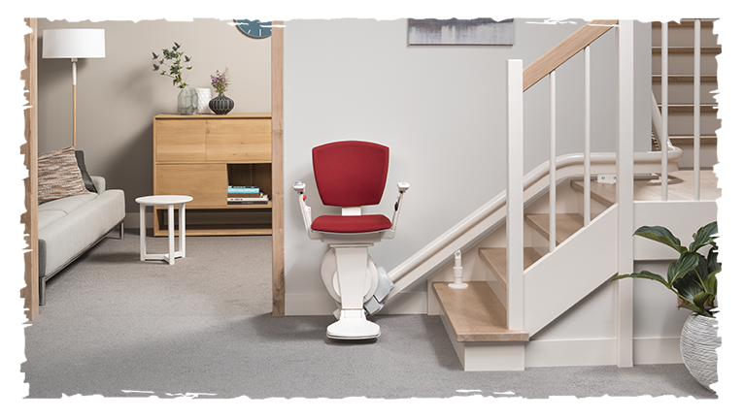

4. Adapted Homes Grant

4.1 The Adapted Homes Grant is intended to help Oxford City residents to adapt their current home. The maximum grant available under this scheme is £8,000 (including any fees and VAT).

4.2 The Oxford City Adapted Homes Grant is similar to the eligibility criteria for the national Disabled Facilities Grant scheme with some exceptions, which are intended to make this assistance easier to approve and more flexible.

4.3 The Oxford City Adapted Homes Grant will be only be available whilst funds permit as it is a discretionary grant. Funding may be withdrawn with immediate effect, however in such instances Mandatory DFG will continue to be available.

Who can apply for an Adapted Homes grant?

4.4 Those persons eligible for a Disabled Facilities Grant or Minor Works Grant are also eligible for an Adapted Homes Grant including any person who is, or is applying on behalf of someone who is:

- registered or registerable as disabled *
* registerable - the person is eligible under the definition of disabled as defined under section 6(1) of the Equality Act

4.5 A person over the age of 18 is eligible to apply for an Adapted Homes Grant under the same criteria as a Disabled Facilities Grant, this can be for themselves or on behalf of the disabled person if they:

- own their own home as a freeholder or leaseholder (with at least 5 years left to run),
- are a tenant or life tenant,
- or have a license to occupy a park home on a licensed site and live in the Oxford City.

What other criteria is there?

4.6 Only one application a year per person can be made for an Adapted Homes Grant.

4.7 The person applying for the grant will normally need to confirm that the disabled person (this could be themselves or somebody that they are applying for intends to live at the property subject to the Oxford City Adapted Homes Grant for the next five years, as their main residence.

4.8 If the property is jointly owned, the applicant will need to get the written consent from any joint owners (who do not live at the property as their main residence), that they confirm the eligible works can be completed to the property.

4.9 If the applicant is a tenant, the applicant will need to obtain the written consent of the property owner agreeing that the eligible works can be completed to the property.

Test of Financial Resources

4.10 Any grant eligible works paid under this grant will not be subject to a ‘means test’ of the financial resources of the disabled occupant. Therefore in such cases the disabled occupant will be entitled to receive a full grant to cover the cost of the eligible works up to £8,000 (including any fees and VAT).

4.11 Unless otherwise stated in this document all other aspects of the provision of Disabled Facilities Grant under the Housing Grants Construction and Regeneration Act 1996 and associated regulations and guidance shall apply including the list of eligible works.

What works are eligible?

4.12 In considering the eligible works Oxford City consult a suitably qualified professional which includes an Occupational Therapist.

4.13 The cost of the eligible works shall be determined so as to provide ‘best value’ and maybe decided by an appropriate schedule of rates, a ‘mini tender’ process or in exceptional circumstances, a single quotation for the eligible works.

4.14 Minor Works up to £1,000 are referred by Social Services, and undertaken by Oxford Direct Services adaptation team. For works that exceed the £1,000 limit the Adapted homes grant can be used to top-up funding for these works. In this case the existing Direct Services single quote will be used to expedite these urgent works.

4.15 The eligible works shall be ‘necessary and appropriate’ to meet the needs of the disabled occupant and it must be ‘reasonable and practicable’ to carry out the relevant works having regard to the age and condition of the dwelling.

4.16 Regard shall be had to the associated guidance and good practice in determining these factors.

4.17 The maximum grant payable for eligible works is £8,000, including the cost of any associated ‘preliminary and ancillary charges’ associated with the eligible works.

5. Relocation Grant

5.1 The Oxford City Relocation Grant can provide financial assistance to help disabled persons move to a more appropriate home.

5.2 An applicant may also apply for assistance for expenses incurred in moving to a more appropriate home outside of the local housing authority area where they live, which maybe within or outside of Oxford City.

Eligibility

5.3 To qualify for this type of assistance the applicant must be:

- a person who would otherwise qualify for a mandatory Disabled Facilities Grant, were it possible to carry out the works; and
- whose contribution towards the cost of the works would, using the test of resources prescribed by the Government for determining mandatory Disabled Facilities Grants, be less than £5,000; and
- is an owner-occupier whose principal or only residence is within the City of Oxford.

5.4 To qualify, the Council must be satisfied that either:

- it is not practicable to carry out works that would be considered “necessary”, “appropriate” and “reasonable” under section 24 of the Housing Grants, Construction and Regeneration Act 1996, or
- The ‘new’ property shall in the opinion of the Oxford City HIA provide a long term, sustainable home for the person for whose benefit the works are required so that either an adaptation is not necessary or the new adaptation is significantly smaller than the original DFG request. The total cost incurred in the eligible relocation expenses at the ‘new’ property should not be greater than the cost of adapting the applicant’s current home.
- the works cannot be carried out without the permission of a third party and that permission has not been forthcoming.

5.5 The Council will not provide this type of assistance retrospectively. The Council will only consider an application for this type of assistance where it has notified the applicant in writing that one of the three criteria listed above apply.

5.6 In exceptional circumstances, the Council will consider providing assistance to enable a private tenant to move to more suitable accommodation.

Eligible Costs

5.7 The Council will pay any of the following reasonable costs subject to satisfactory evidence that the expenditure has been incurred:-
- Stamp duty;
- Mortgage arrangement fees;
- Estate agents’ fees;
- Furniture removal costs;
- Utility connection costs;
- Conveyancing costs and/or;
- Any other costs that are deemed by the Council to be essential to effect
the move;

5.8 This is subject to a maximum total level of assistance of £15,000 per applicant.

Application

5.9 An application shall be made in a format prescribed by the Council. Application Forms are available on request.

Conditions

5.10 A person who receives relocation assistance shall not be entitled to claim similar assistance for a period of 10 years. However, the provision of this type of assistance does not remove the right of any person to apply for a mandatory Disabled Facilities Grant at any time.

Payment

5.11 A single payment will be made to the applicant upon completion of the move and upon receipt of satisfactory copies of any receipts, demands or other evidence of payment.

6. Discretionary Disabled Facilities Grants

6.1 The Council will consider applications for discretionary Disabled Facilities Grants in exceptional cases. These grants may be applied for either on their own or in addition to a mandatory Disabled Facilities Grant (DFG).

6.2 These grants will be subject to the client having a “nil contribution” from the mandatory DFG prescribed test of resources and will be subject of a maximum of £10,000 each year.

6.3 Assistance is limited to properties within the City of Oxford and applications will be considered for:

- Helping to pay towards a mandatory DFGs which has exceeded the £30,000 limit.

- Adapting or providing a room for the use of a housebound person with a disability for the purpose of receiving specialised care or medical treatment, which on expert medical or other advice, is best delivered at home.

- The provision of a safe play area for a child, with disabilities, under the age of 10 at the date of application for a grant.

- Essential repair of adaptations fitted under a DFG in order to keep a disabled person safe after the warranty period.

- Essential repairs/works to the client’s property in order to either enable a DFG to take place or to enable hospital discharge.

- Other works to provide a solution for vulnerable and disabled applicant’s needs. This would be subject to authorisation by the Head of Service.

- Where applicants have a contribution to make according to the outcome of the prescribed test of resources, they may provide written evidence to the Council, from an Independent Financial Advisor of their inability to raise sufficient funds to cover their own contribution. In these circumstances the City Council will consider approving discretionary grant aid if that is the only option for enabling the agreed works to proceed. The City Council may seek further advice before determining the application.

- The maximum grant is £10,000. The grant may include the cost of the eligible works plus an agency fee which is charged at the current rate
(a minimum £10 agency fee applies).

7. Safe and Secure Grant

7.1 The Safe and Secure Grant is designed to enable home owners and tenants* to quickly access financial assistance to carry out a wide range of minor adaptations and small repairs to reduce risks and accidents around the home, promote independent living and assist with hospital discharge or prevent hospital admission.

7.2 This is a discretionary grant and therefore such assistance only remains available while funds permit. Funding maybe withdrawn with immediate effect for grants yet to be approved.

Who can apply for a Safe and Secure Grant

7.3 A person is eligible to apply for a Safe and Secure Grant if they are over 18 years old, live in the local authority area of Oxford City and:

- The applicant must be registered as disabled (or able to be registered) or over 60 years of age.
- own their own home as a freeholder or leaseholder (with at least 5 years left to run),
- are a tenant* or life tenant,
- or have a license to occupy a park home on a licensed site and;

*this grant assistance will not be provided for tenanted properties where the eligible works are the normal, legal responsibility of the landlord.

7.4 At the Oxford City HIA discretion, a grant will be considered for the reasonable cost of the work necessary to:

- carry out minor works to enable independent living
- works to prevent falls in and around the home
- reduce hazards or risks that are likely to cause serious harm or injury
- works to enable hospital discharge or prevent hospital admission.
- examples of eligible works may include:
  - water supply, drainage and heating issues
  - electrical and gas safety
  - small adaptations to support for Dementia
  - repairs or modifications to stairs, floors and steps
  - safety and security repairs
  - adaptations to enable independence and safety

Amount of Assistance

7.5 The maximum grant is £2,000. The grant may include the cost of the eligible works plus an agency fee which is charged at the current rate (a minimum £10 agency fee applies).

What conditions are attached to the grant?

7.6 For simple works carried out by the Oxford City Council Handyperson, no quote is required. The Handyperson will complete the works on-site with the client.

7.7 For most other Safe & Secure jobs no quote is required. The work will be undertaken by Oxford Direct Services to expedite works.

7.8 For all other specialist works one quotation from an Oxford City HIA contractor shall be submitted for the cost of the eligible approved works. No works shall be carried out without formal grant approval.

7.9 Once all the above paperwork is received or obtained by the Oxford City HIA service to their satisfaction, then the application will be considered complete.

7.10 Once an application is considered complete, the Oxford City HIA service will in eligible cases approve a grant in accordance with any agreed response time.

7.11 The grant will only be paid upon the successful completion of the works to the satisfaction of the Oxford City HIA service and upon receipt of suitable invoice(s).

7.12 Grant monies will only normally be paid directly to the contractor who performed the eligible works.

8. Oxfordshire County Council – Lift Service and Maintenance Contract

Historically there are some lifts under a service and maintenance contract with Oxfordshire County Council.

Children’s lifts fitted under a mandatory DFG are also added to this list once the warranty has expired.

8.1 The assistance below will only apply to lifts on Oxfordshire County Council’s service and maintenance contract within Oxford City.

8.2 Funding will be made available for an annual service and inspection visit for those lifts on the list with an approved OCHIA contractor.

8.3 Small repairs to lifts on the list also will be funded. If the lift becomes uneconomic to repair it will be referred back to Oxfordshire County Council to re-assess the client to make sure it still meets their needs.

8.4 Once a suitable referral is received from an OT the replacement lift can be considered under Mandatory DFG.

8.5 Repairs can still be considered to keep the old lift functional until a new one can be sourced.

8.6 The grant may include the cost of the eligible works plus an agency fee which is charged at the current rate (a minimum £10 agency fee applies).

9. Essential Repairs Assistance (ERA)

Eligibility

9.1 Applications will be considered where the applicant(s):

- Are over 18 years of age;
- These grants will be subject to the client having a “nil contribution” from the mandatory DFG prescribed test of resources and will be subject of a maximum of £5,000 per application.
- Occupies the property, within the City of Oxford, as their sole or principal residence in the United Kingdom.
- Has repairing liability in law; and
- Other than in exceptional circumstances, has lived in his/her home for a minimum of three years.

9.2 If an applicant meets these criteria, then under any of the following circumstances financial assistance may be available.

- Where a risk to the security of the occupier exists e.g. insecure windows or doors.
- Where a breakdown of the primary source of heating or hot water has arisen or where it is so defective that a breakdown is inevitable.
- Where a major defect exists that puts the health and safety of the occupier at an unacceptable level of risk e.g. an unsafe gas or electrical system.
- Where there is a significant risk to public safety e.g. from an unsafe chimney of loose roof coverings.
- Where internal works that pose an immediate risk to the occupier, their carer or other visitors to the property exist e.g. rotten flooring or a dangerous staircase.
- Where a major structural element is so defective that significant further damage to the structure of the property or an adjoining property, will arise if remedial action is not taken e.g. a badly leaking roof or leaking gutters or downspouts.
- Where there is a serious risk to health that is directly attributed to the repairs or adaptations required. In some cases medical evidence of need may be required e.g. from a GP or Hospital Consultant.
- Where a notice requiring repair would otherwise be served or where a higher level of enforcement action would be necessary e.g. making a Closing Order and re-housing the occupier.
- Where properties have a low Standard Assessment Procedure Rating (SAP 60 or below), grant assistance to meet the Decent Homes Standards will be available.

Amount of Assistance

9.3 A maximum of £5,000, per property, is payable to execute repairs in any three year period where the works fall within the above list. The grant may include the cost of the eligible works plus an agency fee which is charged at the current rate (a minimum £10 agency fee applies).

TARGET STANDARD OF REPAIR
The target standard of repair to be achieved is one which will remedy the defect and which will remove the associated health risks. Renewal of a failed element will take place when this is the most cost effective remedy. For example, a leaking roof may require either repairs or renewal of one or more roof slopes; or the whole roof may need to be stripped and re-laid. If the roof is generally sound and is judged to have at least 10 years further life, it will be repaired. Replacement windows will have to meet the Building Regulation standards and other standards, e.g. in conservation areas or if the property is a Listed Building.

Conditions

9.4 All Financial Assistance over £1,000 is subject to the following conditions:

- Sale or transfer of a property within a 10 year period from the date of completion of any works will result in the money being repayable in full.
- Any financial assistance paid will be based on a specification for works that has been either provided by, or approved by, the Council. Specifications that are not approved by the Council will not be accepted. Quotations based on unapproved specifications will not be acceptable.
- The contract for any works undertaken is between the applicant and the contractor
- In general, at least two quotations are required for works that will cost over £1,000, unless prior agreement has been given by the Council (or its agent), the case is one of emergency, or the work is of a specialist nature not normally carried out by building contractors. All quotations must be itemised (to assist with settlement of any variation in cost or dispute that may subsequently arise), be on proper letter heading and be dated.

10. Flexible Home Improvement Loans (FHIL)

10.1 Oxford City Council is part of a consortium of 17 local authorities who have been awarded funding from the South East Regional Housing Board for a not-for-profit Flexible Home Improvement Loan Scheme. The local authorities have created Flexible Home Improvement Loans Limited, which is a not-for-profit company, limited by guarantee and wholly owned by local authorities across Berkshire, Buckinghamshire, Oxfordshire and Surrey.

10.2 The eligibility requirements, scope of works, and the general requirements governing FHIL’s are prescribed and the Council is unable to deviate from these requirements.

Eligibility

10.3 To qualify for this type of assistance the applicant must be an owner-occupier aged 60 or over, and living in the City of Oxford. In the case of joint owners, each must be at least 60 years of age.

Eligible works

10.4 We will consider improvements that will make the home safer, warmer, healthier or more comfortable for the occupants. Examples of work that may be acceptable include essential repairs and maintenance, central heating or improvements to heating, replacement doors and windows, home security and the installation of adaptations such as level access showers.

Amount of Assistance

10.5 The minimum amount of assistance is £1,000 and the maximum is based on the property value.

Conditions

10.6 Loans are subject to conditions which are set by FHIL and agreed by the client in writing.

- The loan will be secured by a charge on the property.
- The interest rate is fixed for the term of the loan.
- During the term of the loan the recipient can choose to make regular monthly payments, occasional payments or no payments at all. The repayment arrangements can be varied at any time by the loan recipient.
- The loan plus outstanding interest must be repaid if the home is sold, or if the owners cease to occupy it.

Fees and charges

10.7 There will be the following fees and charges associated with the loan:

- There will be a fee of £30 for the loan documentation and legal charge, plus a fee to the land registry, which will be quoted at the time of the application.
- There is an annual charge of £15 to cover the cost of loan administration and statements.
- If Oxford City council HIA team manage the works on behalf of the client an agency fee will be charged at the current rate.
- Any fees incurred by the applicant may be added to the loan.

11. Empty Homes Loans

How does the scheme work?

11.1 Flexible Home Improvement Loans Limited offer Empty Homes Loans. Empty Homes Loans may be regarded as 5 year, flexible, bridging finance secured by a first charge or, in some circumstances, a second charge on the property.

11.2 After the work has been completed you may let the property or use it as your own residence. During the term of the loan you can choose to make regular monthly payments, occasional payments or no payments at all. Furthermore, you are free to vary the arrangement at any time.

11.3 The loan, plus outstanding interest, must be repaid on the fifth anniversary of making the loan, or if the property is sold, whichever occurs first. The borrower will normally need to remortgage, or sell, the property to repay the loan. Interest will be charged at 2% above Bank of England rate, subject to minimum and maximum rates (please contact us for a quotation). Your account will also be debited with an annual charge of £15 to cover the cost of loan administration and statements.

11.4 The loan may be repaid, in whole or part, at any time before the end of the five years, without penalty. When the loan is completely repaid there is a flat fee of £50.00 for cancellation of our registered charge

Who is eligible?

11.5 Empty Homes Loans are available to owners of empty properties and anybody wishing to purchase an empty property.

11.6 Applications are processed on a non-status basis, although a credit check is carried out. A very poor credit history may result in the application being declined and bankruptcy will automatically prevent us from making a loan.

Are there any setting-up costs?

11.7 There will be a fee for loan documentation and registration of the legal charge. The fee will be added to the loan and is currently £80.00 for loans up to £100,000. In certain circumstances the Council may need to obtain a valuation of the property to confirm the equity is sufficient to cover the loan. This is unlikely to be needed in the majority of cases.

11.8 If you decide to engage a solicitor to act for you, they will almost certainly charge for their service. Any fees incurred may, if you wish, be added to the loan.

12. Small Repairs Scheme

Handyperson Services

12.1 A handyperson service provides a range of practical support services for older and disabled people with the aim of helping them maintain independent living. Oxford City Council currently provides a chargeable Handyperson Service for a wide range of jobs which can include:

- Small building repairs
- Minor adaptations
- Odd jobs such as putting up curtains, shelves, replacing light bulbs.
- General home safety checks and remedial actions
- Falls and accident prevention checks and remedial actions such as repairing floor coverings
- Security checks – installing locks, chains and spyholes
- Fitting handrails and fitting “keysafes”
- Installing smoke detectors (including special smoke alarms for the deaf)

12.2 This list is not exhaustive but generally work should be considered as ‘small repairs’ that can be completed quickly.

Who can use the scheme?

- Disabled people over 18 years old.
- Older vulnerable people (over 55 years of age). Priority will be given to those households and individuals who are disabled or in receipt of income support or other means tested benefits.
- Homeowners and private tenants (but not for works that are the responsibility of the landlord).
- Residents of Oxford City.

Charging

12.3 The costs are based on an hourly charge (this is currently £20 per hour) plus the cost of materials. Costs will vary from job to job and free quotations are given.

13. Property MOT

13.1 Home owners who are eligible for ERA or the Small Repairs Scheme can contact the Council to request a ‘Property MOT’. This will take the form of an assessment covering the major elements and identifying both existing and anticipated repairs/replacements and any other significant shortcomings within the dwelling. The ‘Property MOT’ will help owners to prioritise works; have a better understanding of the condition of their homes and, for those who are able, to investigate loan options. Having a better understanding of the overall condition of their property will allow owners to consider the total cost of any works and evaluate their property and options.

14. House Boats

14.1 Financial assistance is available to qualifying households (Based on ERA criteria) to cover essential repairs required to meet the minimum standards required by Canal & River trust under the Boat Safety Scheme and appropriate energy efficiency measures.

14.2 A maximum of £5,000, in any three year period is payable.

15. Mobile Homes

15.1 Financial Assistance is available to qualifying households (based on ERA criteria) to cover essential repairs and appropriate energy efficiency measures.

15.2 It should be noted that both residential houseboats and mobile homes have a limited life and that an assessment of the anticipated future life of the structure will be undertaken before grant aid is approved. A minimum anticipated future life of 4 years is required. Owners of structures with a shorter anticipated life will receive assistance to carry out temporary or emergency repairs sufficient to enable other housing options to be explored.

15.3 A maximum of £5,000 in any three year period is payable.

16. Paying for Staff

16.1 Some local authorities have engaged in-house Occupational Therapists where extended waiting lists occur and covered the costs using the Better Care Fund (BCF) funding. Oxford City Council may use BCF funding to engage an Occupational Therapists or other similar support posts in order to help meet the directives of the BCF funding. This will be referred and approved by the Head of Service

17. Administration

How to Apply for Assistance

17.1 Assistance will be provided through the Councils’ Home Improvement Agency (HIA). Enquiries can be made in person at St Aldates, by telephone (01865 252887), in writing (HIA Team, St Aldate’s Chambers, 109 St Aldate’s, Oxford OX1 1DS, by e-mail, hia@oxford.gov.uk or via the Council’s Website (www.oxford.gov.uk/hia).

17.2 A preliminary enquiry system will allow enquiries to be routed quickly to the most appropriate form of assistance. Enquirers will be advised wherever delays are likely, including the likely length and the reason for a delay.

17.3 The preliminary enquiry system will help to ensure that higher risk cases are dealt with first if delays are likely. For low priority cases a waiting list will be kept.

Grant Conditions

17.4 All works for which discretionary grants and assistance are awarded must be completed within 6 months, or such longer period of time that has been agreed in writing by the Council. No retrospective applications will be considered.

17.5 All works must be completed in accordance with a specification of works agreed by the council. The agreed works must be carried out to a satisfactory standard of workmanship.

17.6 The payment of any form of financial assistance will be subject to bona fide invoices being provided by the approved contractor or in exceptional circumstances, with the approval of the casework officer, an alternative contractor. For example if the original contractor is unable to carry out the works.

17.7 The Council may give a qualified financial assistance approval in certain circumstances. For example, approval may be given for a scheme of works with payment not being guaranteed until the following financial year. This will allow some payments to be made for preliminary or ancillary fees. For example fees for drawings and legal costs.

17.8 Any Essential Repairs Assistance totalling over £1,000 will be repayable on the sale or transfer of a property within a 10 year period commencing with the completion of the works.

17.9 The HIA agency fee at date of publication was 15%, however this is reviewed annually. The current rate can be checked on our website;
https://www.oxford.gov.uk

17.10 The HIA Handyperson rate at date of publication was £20/hr, however this is reviewed annually. The current rate can be checked on our website;
https://www.oxford.gov.uk

18. Applications outside of the Policy

18.1 The Council will consider applications for assistance that are exceptional or fall outside of the policy. In order to make such an application the service below should be contacted in the first instance:

Home Improvement Agency,
Oxford City Council
St Aldate’s Chambers,
109 St Aldate’s,
Oxford
OX1 1DS
Tel: 01865 252887
hia@oxford.gov.uk

18.2 Applications should preferably be made in writing, however in some instances you may wish to seek verbal advice in the first instance.

18.3 Exceptional cases, which fall outside the criteria laid down in the policy, will be approved or referred to the Head of Service.

19. Policy Implementation

19.1 This policy shall come into effect on 11th March 2020. The policy shall subsist until the City Council approves any amendments or a successor policy is approved.

19.2 It is intended that the policy will be reviewed annually and any proposed changes will be evaluated and implemented as soon as practically possible, if adopted.

19.3 Circumstances that might necessitate an earlier review might include changes in the available financial resources or changes to the Councils’ wider corporate strategies.

February 2020

